Portfolio of evidence

By Duran Moodley 13016335

Assignment 2

Contents

Problem Statement 2

Purpose 2

Functionality 2

Additionally Functionality 2

How the Application Runs 3

Screen Shots 4

Flow Chart 15

Class Diagrams 22

Lecturer Feedback and Corrections 26

Enhancements 27

# Problem Statement

## Purpose

An IT lecturer at Varsity College requires an application that can record student answers for Ice Tasks and calculate/mark student answers. The lecturer feels that he’s students currently are not grasping the theoretical aspects of IT programming. The lecturer would like to use the application as a Test to all students. The application should allow the students to browse and open the Ice Task questions on the computer. The student can select one of 4 Options to answer the question (A,B,C,D). Once all 20 questions are answered, the student can change any answer by selecting the Question number on the list box and changing the answer. The application will generate a report once the all answers have been checked by the student. The students can also save their own results. The report will contain the student number of the student, number of correct and incorrect answers and final percentage. The application will also have a back end part to the system. This will allow the lecturer to add the model answers to each question and view a report of each students mark. The lecturer will also be required to enter the amount of students in the class. Once all students have taken the Ice task an email will be sent to the lecturer containing all the students mark.

## Functionality

* Save Records to a text file
* Send Email
* Displays a report
* Calculates Student mark
* Prompts student to answer a series of questions

## Additionally Functionality

* Sends an email

# How the Application Runs

**(Access the Back End of the Application Enter: 49293**

**Access the Front End of the Application Enter any 8 digit Number)**

The Application will start up with a Splash Screen Followed by a login screen. This application contains a back end which can only be viewed by lecturers and a front end which can be viewed by both a lecturer and a student. If a student is running the application he/she will need to enter in their student number which will be saved.

Thereafter, the student will be present with a Rules form. This will tell the student how to use the application.

Once the button “Continue button” is pressed, the Test form will be displayed. It will contain a progress bar at the bottom, a label on the top left hand side which will contain the number of questions and the amount answered. This form will contain five buttons A,B,C,D and a Next button. The student needs to make sure he/she opens the Ice Task questions by click File-🡪 open. The student can browse to the location of the word document. To answer the question the student will have to click next which will then prompt the next question. The application only allows for 20 questions. Once all 20 questions have been answered. The user will be prompted to click the submit button.

This will take the student to the Verify Answers form. This will contain 2 list boxes containing all 20 questions and the student answers. The student can change answer by simply selecting the question. Once the option has been selected it will be shown on a text box where the student can change their answer after clicking the Edit button. Once the student is satisfied he/she can get their results by clicking on Calculate Mark.

This will draw up a report of the student’s results which includes the student number of the student, number of correct and incorrect answers and final percentage. This will all be displayed text boxes on the Student Report form. The student can then Save their results by clicking File -🡪 Save As. This form also counts all the students who have taken the Ice task. If the entire class has completed the Ice task an email of every students mark and their student numbers will be sent to the lecturer.

If the lecturer wants to view a report of all students mark and add a new Ice Task. The lecturer can Enter 11111111 (Eight 1s) into the Login Form. This will redirect the lecturer to the Lecturer menu form. If the lecturer wants to add an Ice task. He/she will need to select Actions --🡪 Add Ice Task, on the Menu Bar.

The Add Ice task form will be shown. This will contain 40 text boxes. 20 text boxes will contain the questions numbers and the other half will be empty text boxes. These text boxes will be for the answers to each question. This is where the lecturer will need to enter in model answer to each answer so that the application can automatically mark the student answer. Once all questions have answers, the lecturer can click Submit.

This will open the Verify Answers form which will do the same function as mentioned previously with some changes. Once the lecturer is satisfied, He/she can click on Confirm which will go back to the Lecturer menu form.

Lastly, the lecturer can also view all student Marks and their student Numbers in a report by Clicking View Report on the Actions Menu list.

# Screen Shots

Splash Screen Form

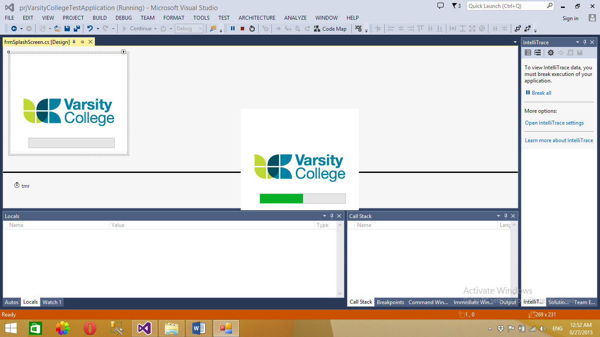

Login Form – Student must enter student number, Lecturer can enter eight 1s to access back end of the system

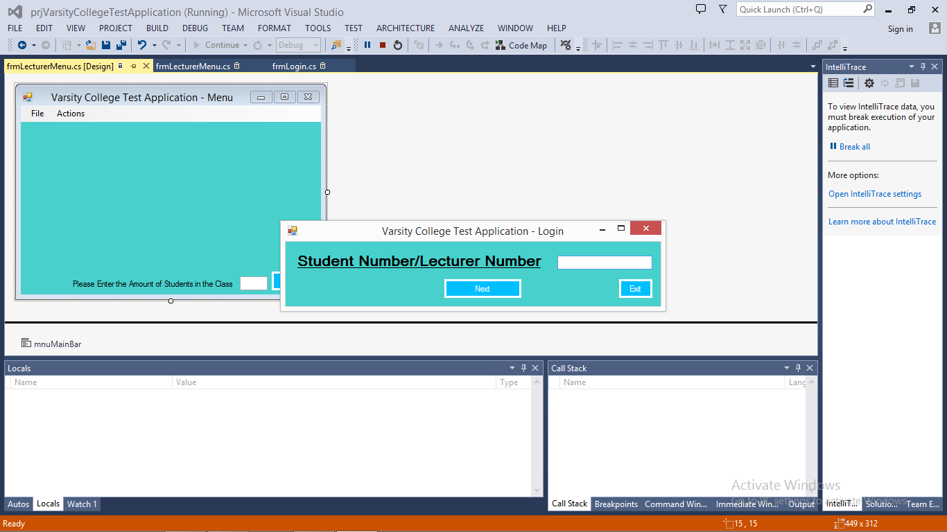

Validation – Student number must be 8 digits long

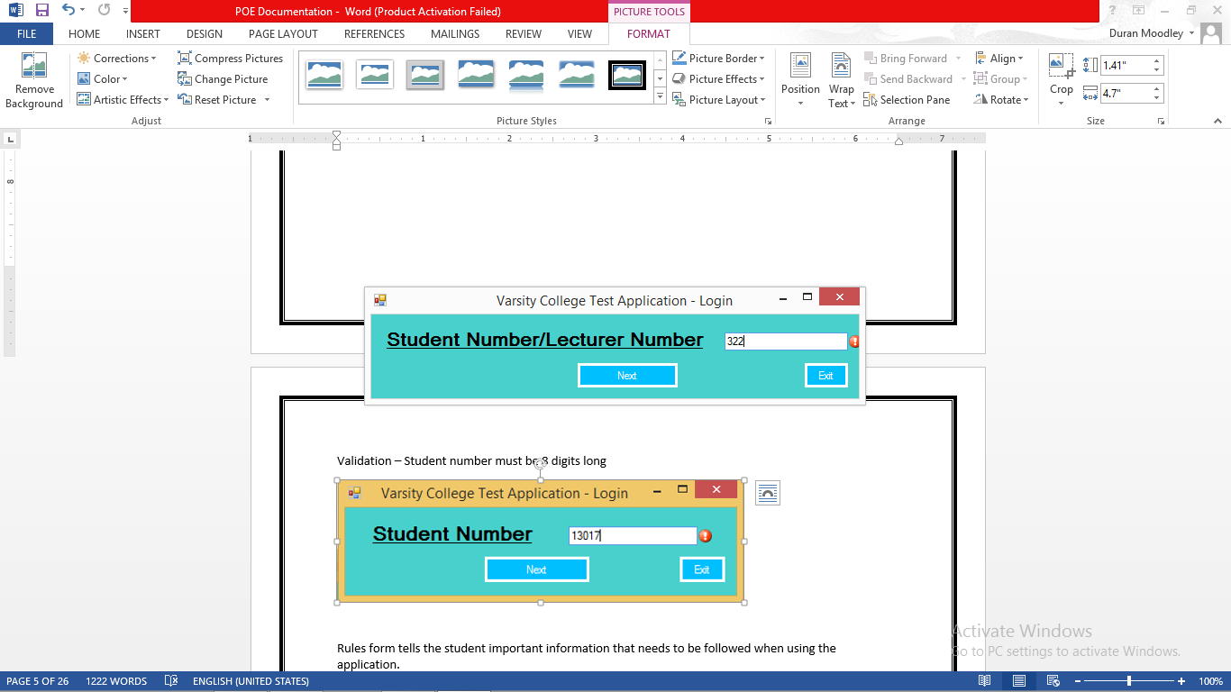

Rules form tells the student important information that needs to be followed when using the application.

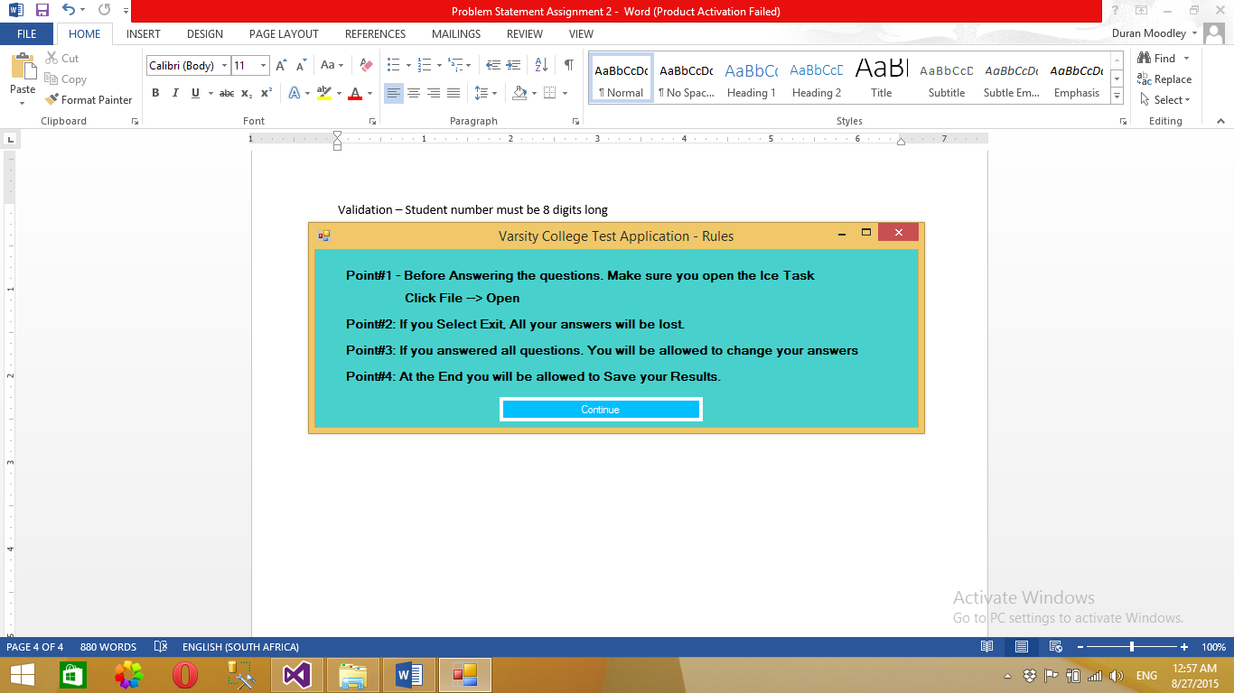

Test form – Allows the Student to select any of the 5 options to answer the Question.

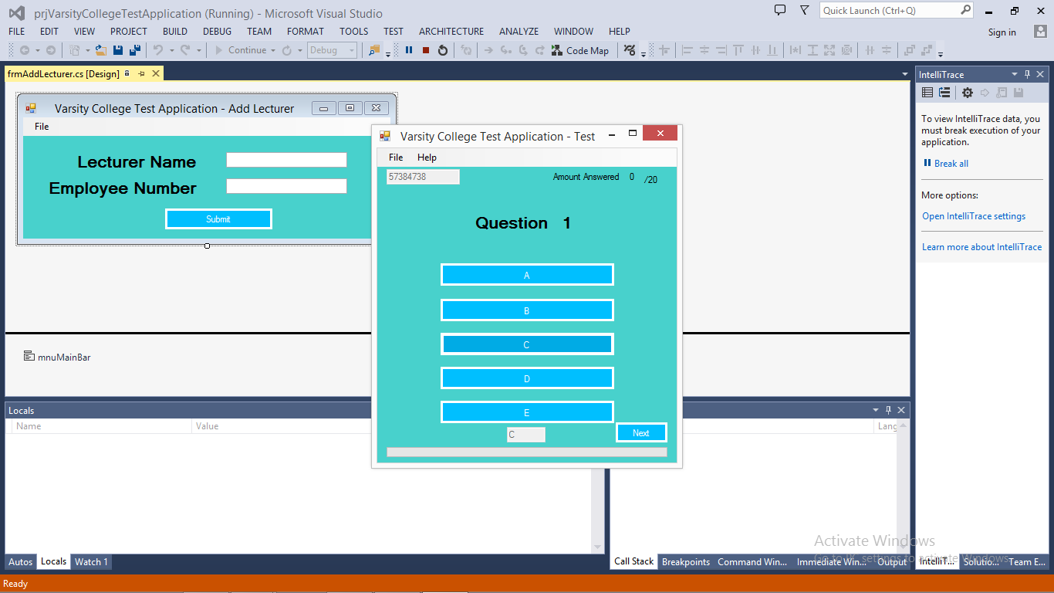

The student can open Ice Task in the application using open file dialog and browse to its location.

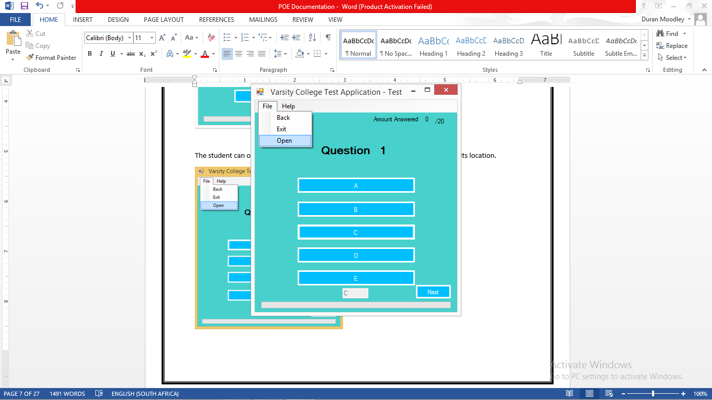

Student is about to Complete Ice Task.

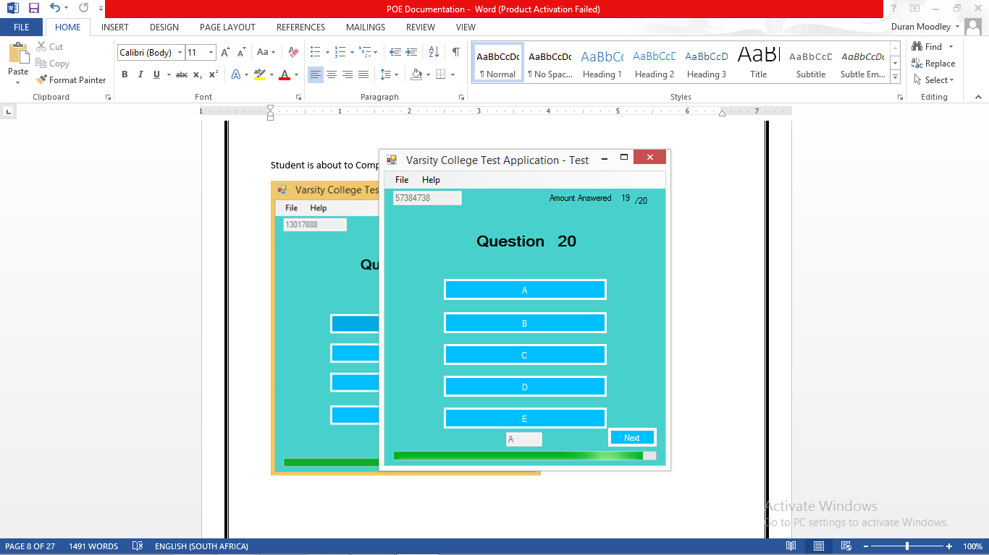

Ice Task is now completed. The student can now submit his answers.

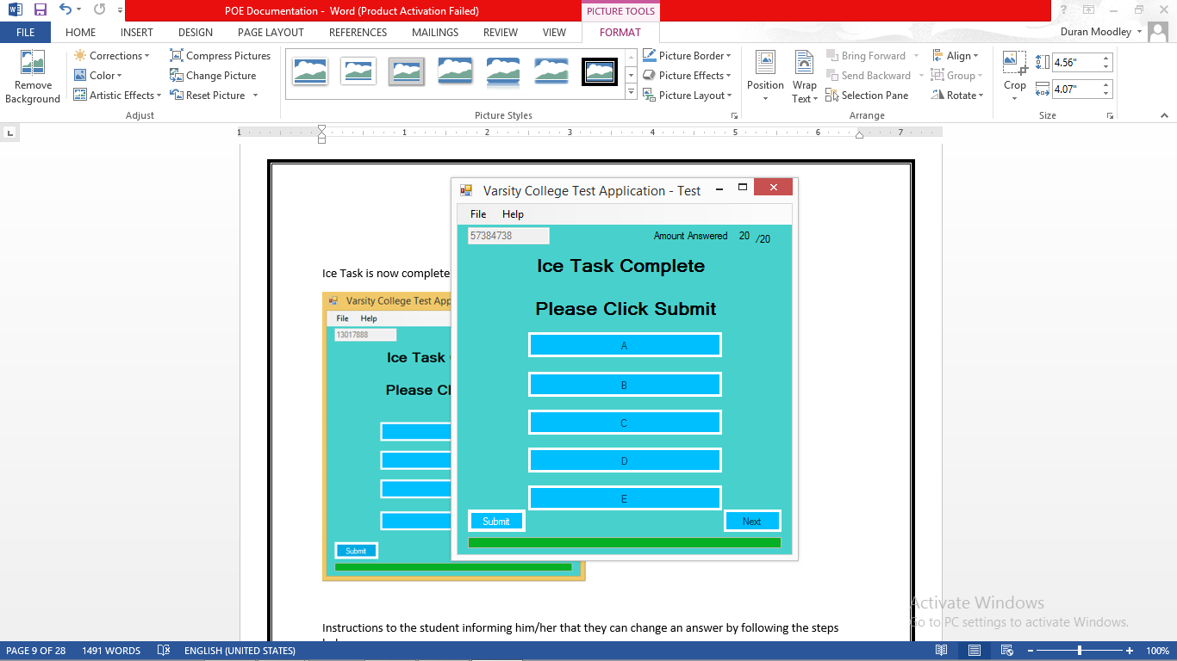

Instructions to the student informing him/her that they can change an answer by following the steps below.

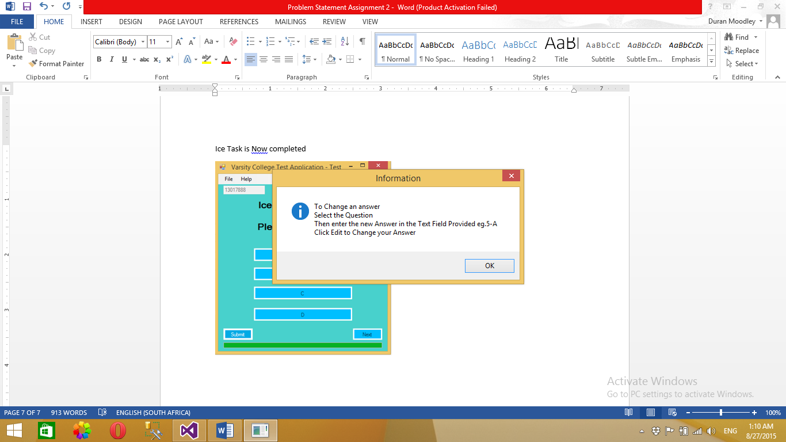

Verify Answers form - Allows the Student to change an answer

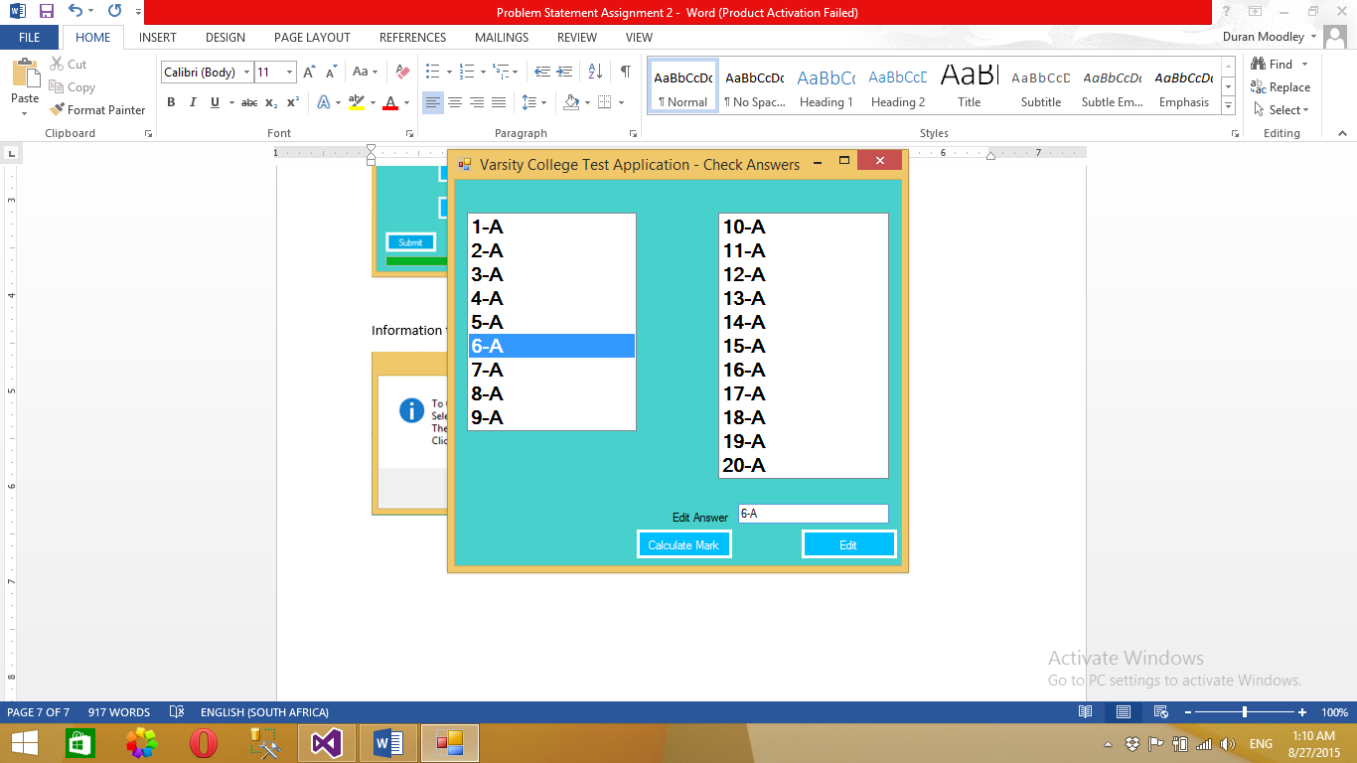

Student Report form which gives the student a summary of their performance in the ICE Task.

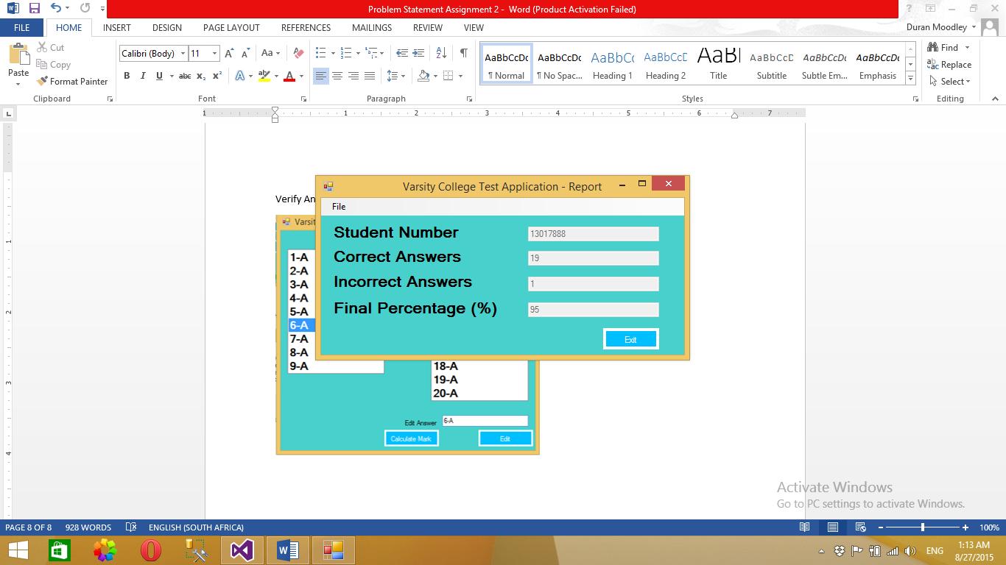

Lecturer Menu Form (Back End) can be accessed by entering (**49293**) in the login form.

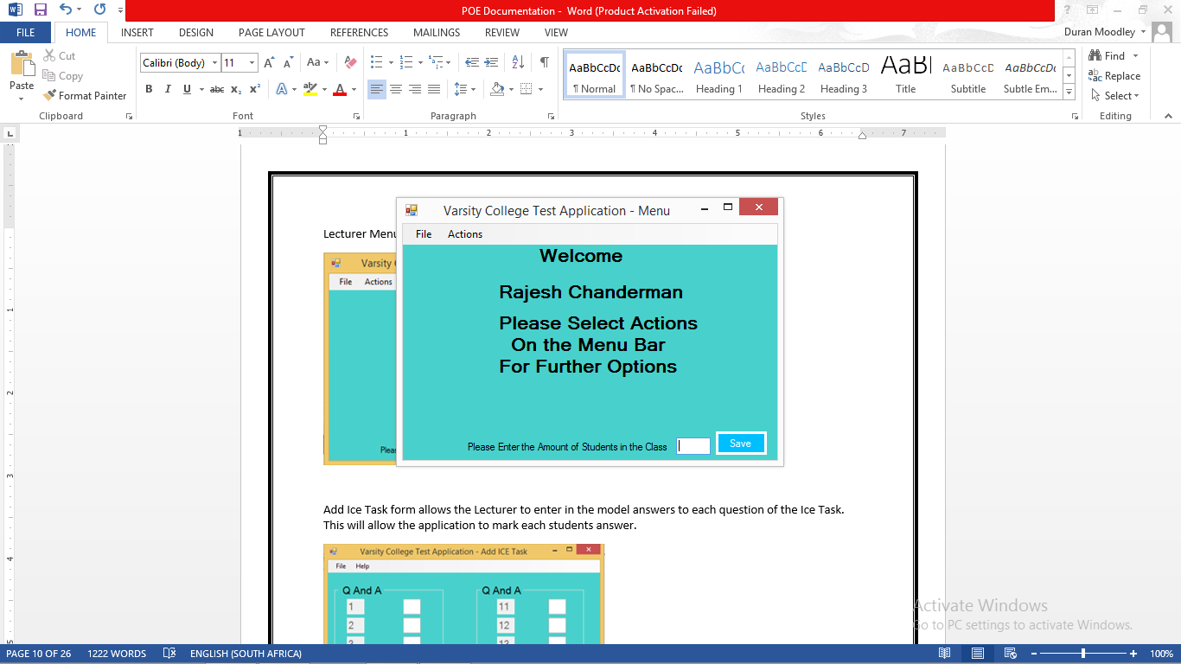

Add Ice Task form allows the Lecturer to enter in the model answers to each question of the Ice Task. This will allow the application to mark each students answer.

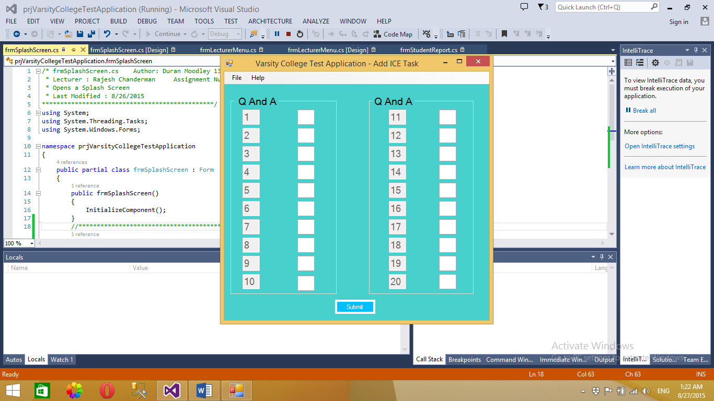

The lecturer needs to enter in all 20 answers to all 20 questions. An error will occur if this is not done.

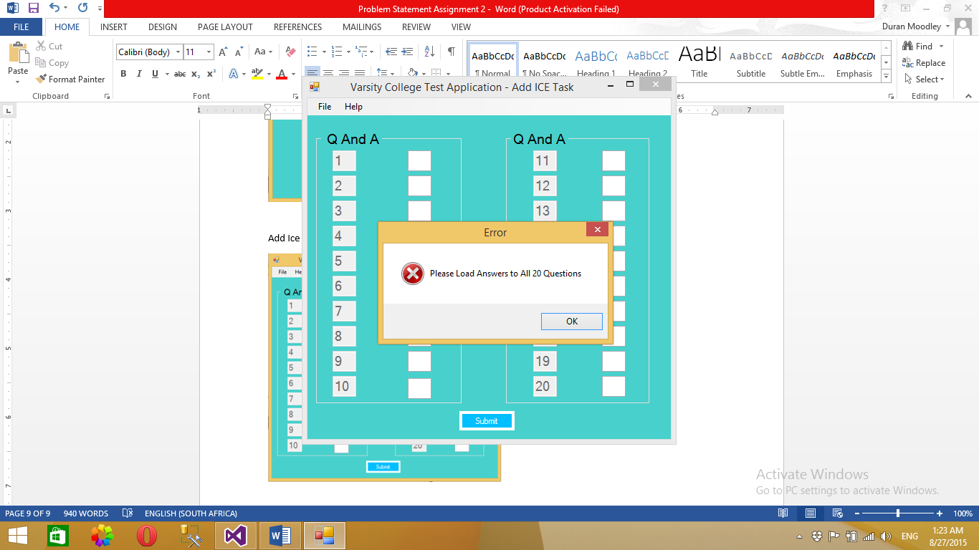

Verify Answers form – Allows lecturer to change an answer entered incorrectly.

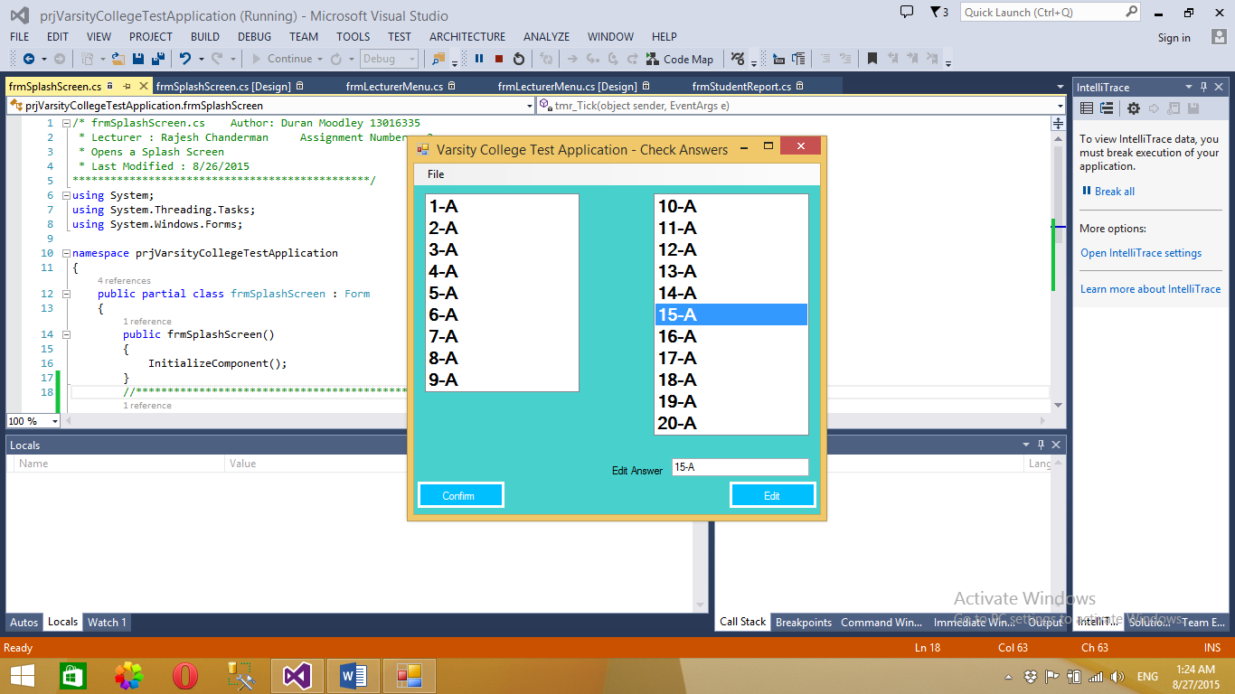

Feedback to lecturer indicating that all answers to each question are saved successfully.

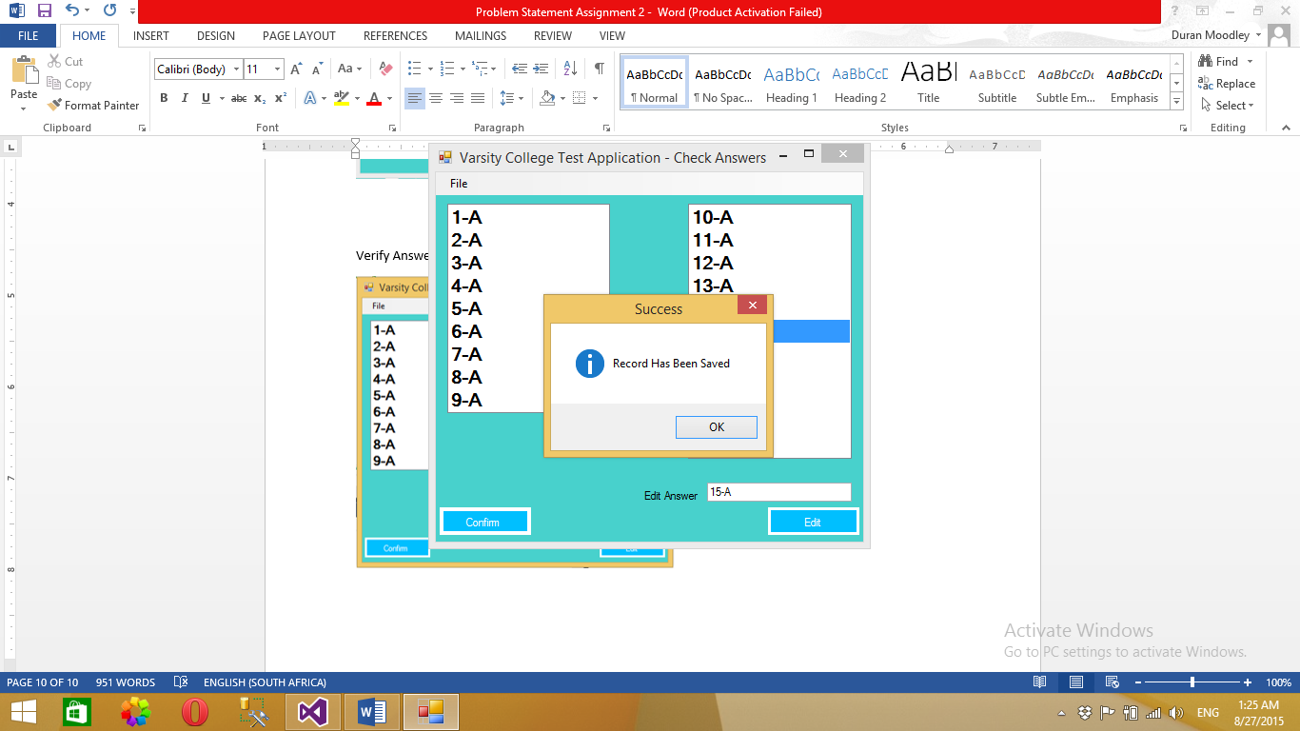

Student Mark Report allows the lecturer to view all student marks.

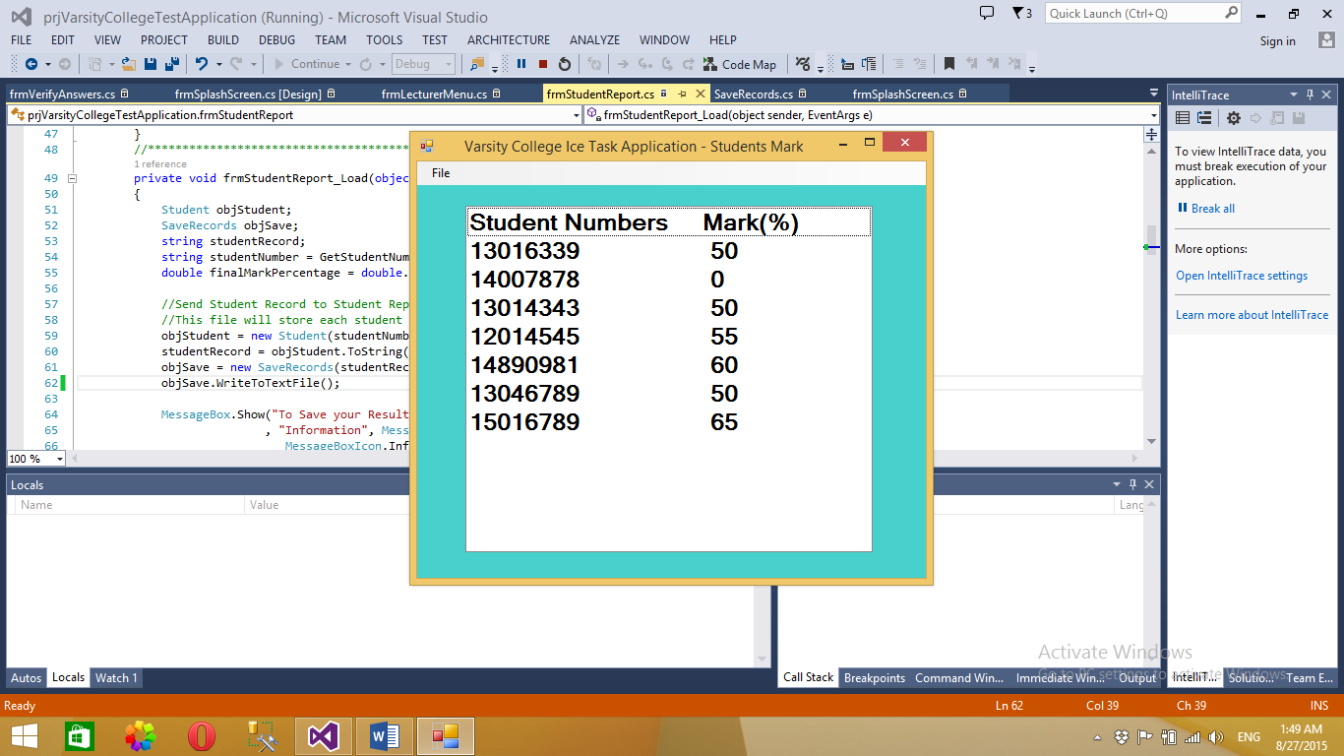

Add lecturer form allows a new lecturer to gain access into the system.

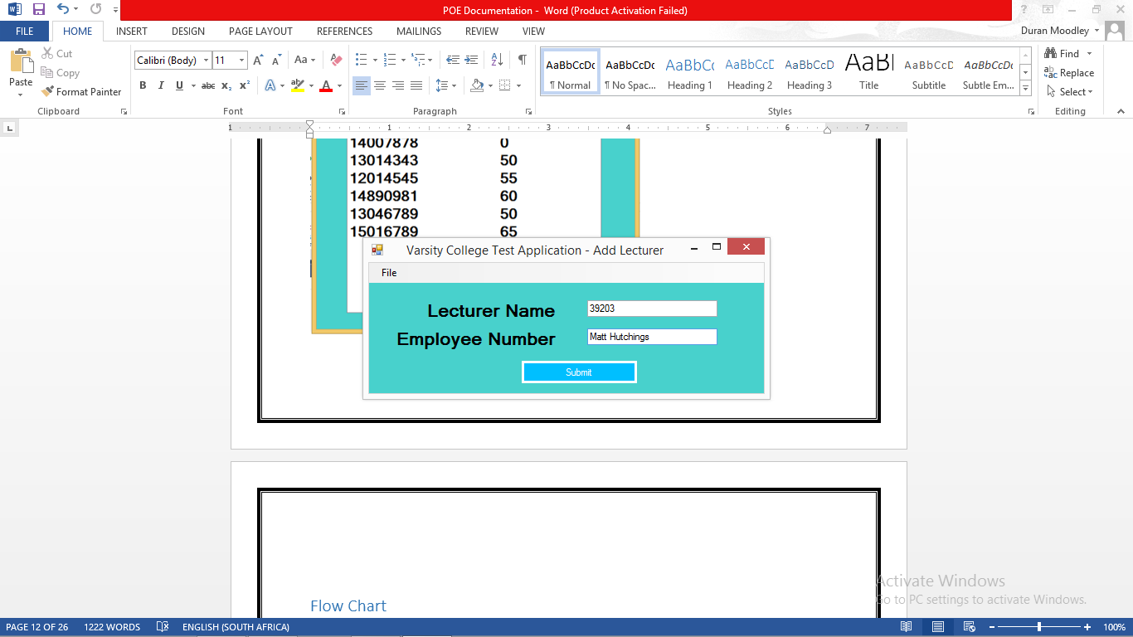

Confirmation message, indicating that the lecturer has been saved

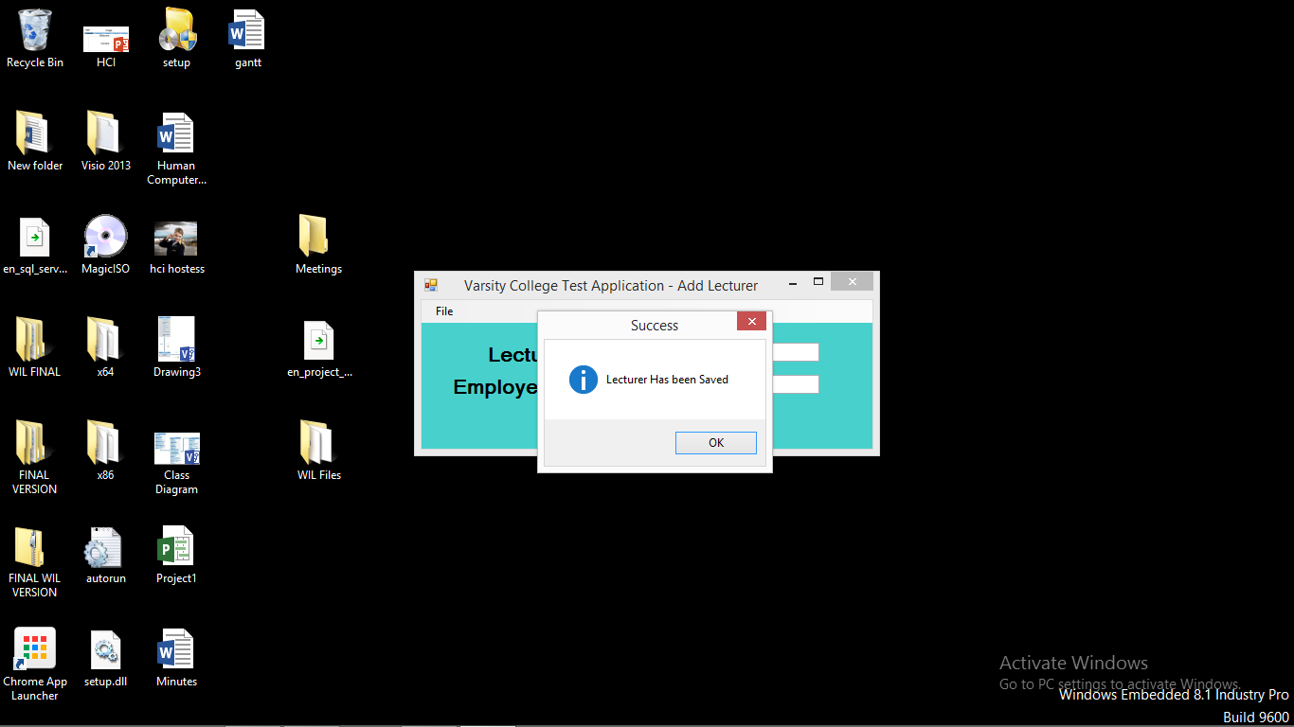

# Flow Chart















# Class Diagrams







# Lecturer Feedback and Corrections

|  |  |
| --- | --- |
| Lecturer Feedback | Corrections Made |
| Change the label student number on Login form to student number/Lecturer number on login screen | Label has been changed |
| Empty constructor in Ice Task class | Constructor has been removed |
| Empty catch statement in form login | Catch statement filled with error message, General catch statement added |
| Code clones picks up 93 lines of duplicated code | Not fixed. Code clones picks up try catch statements. |
| Validate your parameter arguments | Arguments are validated and validate method has been changed. |
| Multiple choice answers should accept 5 answers and not 4. A to E. | Application now accepts 5 answers. A to E. |
| Remove space from file names | Spaces has been removed from file names. |

# Enhancements

* A database class was added to the program
* A lecturer class was added to the program
* A new form was added to the program – add new lecturer
* The application now connects to a database containing a lecturer table. This table stores all lecturers who have access to the system. The fields of this table are lecturer name and lecturer id number. The application now adds a new lecturer and sends the details to the database.
* If a lecturer wants to access the system. The now need to enter in their own lecturer id number. The system now searches for that id number in the database. Once found, the lecturer can now have access to the back end of the system.
* The application also personalizes the menu form by displaying the name of the lecturer on the form. Refer to screen shots.
* The application also passes values from one form to another. This is clearly shown when the lecturer name is shown on the menu form. This values is coming from the login form.
* The student can also verify what answers they are submitting when clicking on the option. If option A is clicked the student can view that option at the bottom of the screen. This will tell the user which option was clicked.